# COMP 3612 Assignment #1: HTML + CSS

#### Version: 1.0 Sept 14 Due Saturday October 7, 2023 at midnightish [i.e, I don’t care about 5-6 hours plus or minus]

## Overview

This assignment provides an opportunity for you to demonstrate your ability to work with HTML and CSS.

## Beginning

I feel foolish saying this in a third-year university course, but it is your responsibility to read all the assignment instructions thoroughly and carefully. If you are unclear about something, ask me. But before you do, read the material in question again!

Starting files can be found at:   
 https://github.com/mru-comp3612-archive/f2023-assign1.git

## Grading

The grade for this assignment will be broken down as follows:

CSS (accuracy, effort, suitability) 50%

Semantic HTML 15%

Functionality (follows requirements) 35%

## Data Files

Images have been provided. I have also provided an additional CSS file for one of the pages.

## Requirements

This assignment consists of two HTML pages with the following functionality:

1. The two pages **must** be named page1.html and page2.html.
2. Your pages should look quite similar to the provided screen captures. When I say “similar” I don’t mean “exactly identical” … different browsers, different browser widths, different platforms: all will affect the appearance somewhat. The purpose of this requirement is for you to learn how to implement a relatively straight-forward design *relatively* accurately. This means margins, paddings, relative font sizes, text styling, etc should be *quite* similar.
3. If you make use of CSS recipes you found online, you must provide references (i.e., specify the URL where you found it) via comments within your CSS file. **Failure to properly credit other people’s work in your CSS will likely result in a zero grade.** You can NOT make use of a third-party CSS library.
4. **Page 1**. The View Form button should be a link to Page 2. Various colors are shown while some of the css properties you will need to alter are shown as well. The hyperlink can be to any working external web page.

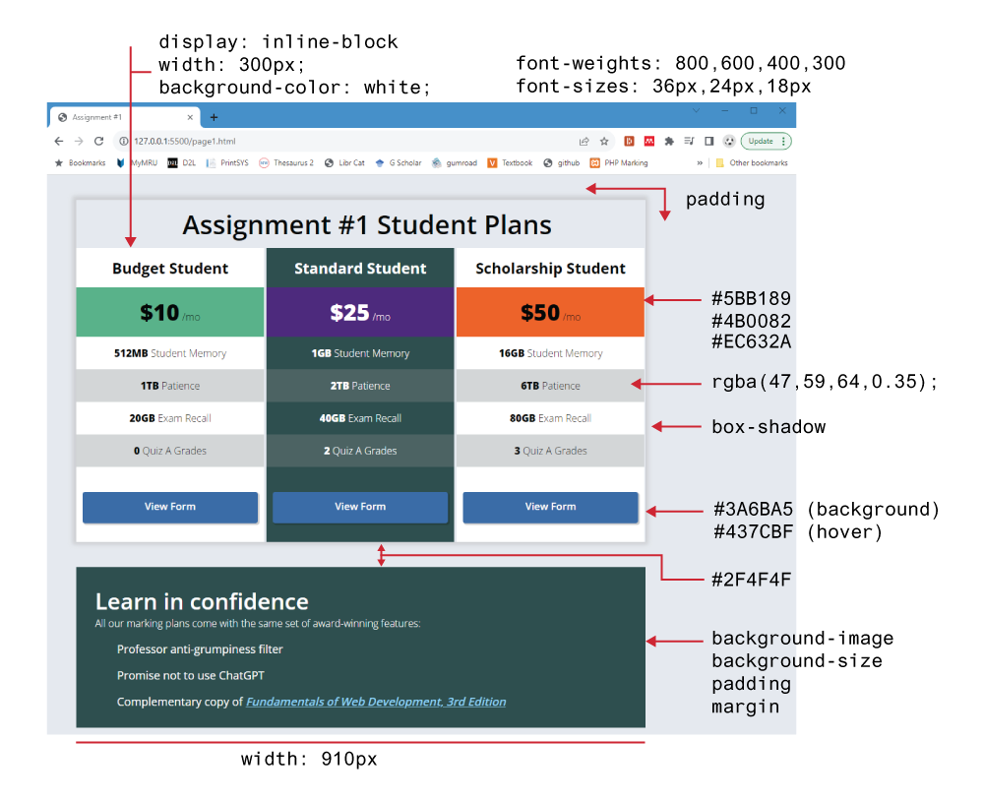

You must NOT use flexbox or grid layout. You can do this with simple inline-block style.

Each of the column <div> elements must have its display property set to inline-block. This will allow the <div> elements to “sit” together on the same lineAlso set some of the other column properties to the values shown above. The second column will have a different background color. Remove the list bullets by setting the list-style-type to none.

For the list items within each column, make every second item a different color using the nth-child pseudo selector. Use the rgba() function, which will darken the underlying background color.

For the bottom “confidence” <div>, the list items have a background image (checkmark.svg). Set the background-size property to 24px. The padding-left and the margin of each <li> item will have to be modified so they don’t overlap the checkmark image. Remove the bullet from each list item.

1. **Page 2**.This page must be a working form, similar to that shown below.

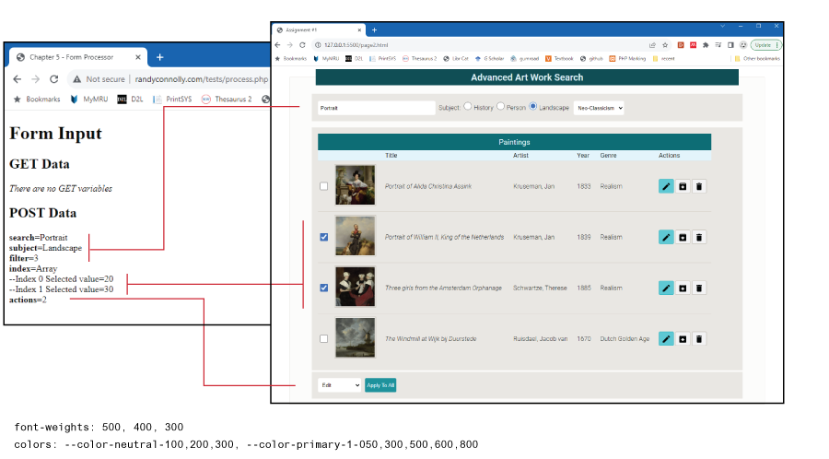

For the Genre list, make the other choices, “Baroque,” “Renaissance,” and “Realism.” For the Bulk Actions list, make the others choices “Archive,” “Edit,” “Delete,” and “Collection.” The dropdown list items should have numeric values starting with 0. The search text box should contain some type of placeholder text.

Create a table of paintings that looks similar to that shown in the figure. The checkboxes in the table should be an array of elements—for example, <input type="checkbox" name "index[]" value="10" />. The name and values are arbitrary, but each checkbox needs to have a unique value.

The action buttons in each row are a series of <button> containers with the type="button" attribute (this prevents them from submitting the form) and an image within the button.

Set the form’s method attribute to POST and its action attribute to http://www.randyconnolly.com/tests/process.php. Be sure to name the form elements as shown in the screen capture.

The colors are defined within variables-palette-7.css. You will have to use the var() function in CSS.

## Submitting and Hosting

Your assignment source code must reside on GitHub and reside on a working public server (in this case GitHub Pages).

GitHub Pages works in conjunction with git and github. You push your html/css/images to github repo; and then push to the host. The instructions for doings so can be found at:  
  
https://docs.github.com/en/pages/getting-started-with-github-pages/creating-a-github-pages-site

It is up to you whether you want your pages to be public (available to the world) or private (available to only those with access to your github repo).   
  
If you are using a private repo, you must add me as a collaborator!

**When your hosting is working and the assignment is ready to be marked, then send me an email with the following information:**

* The URL of page 1 of the site on github pages.
* The URL of the github repo so that I can mark the source code. If your repo is private, then add me as a collaborator!